**Seminar Hall Booking System: A Django - Based Solution**

**Abstract:**

In today's educational and corporate environments, efficient management of seminar halls is essential for organizing events, meetings, workshops, and various activities. Traditional methods of booking and managing these spaces can be cumbersome and error-prone. Therefore, the implementation of an automated Seminar Hall Booking System (SHBS) is crucial for streamlining the process and ensuring optimal utilization of resources.

This project focuses on the development of a Seminar Hall Booking System using the Django web framework. Django offers a robust and scalable platform for building web applications with features such as authentication, data modeling, and URL routing, making it an ideal choice for this endeavor.

The SHBS allows users to browse available seminar halls, check their availability, and reserve them for specific dates and times. Users can register and login to the system, providing a personalized experience and enabling them to manage their bookings efficiently. Administrators have access to additional functionalities such as adding new seminar halls, managing user accounts, and generating reports on hall utilization.

**Key features of the Seminar Hall Booking System include:**

1. User Authentication and Authorization: Secure registration and login system for users and administrators with role-based access control.
2. Seminar Hall Management: Browse, and view details of available seminar halls including capacity, facilities, and availability schedule.
3. Booking Management: Reserve seminar halls for specific dates and times, with options for canceling bookings.
4. Administrator Dashboard: Access to administrative functionalities for managing users, seminar halls, bookings, and generating reports.
5. Reporting and Analytics: Generate comprehensive reports on hall utilization, booking trends, and user activity to aid in decision-making.

The Seminar Hall Booking System aims to enhance the efficiency of managing seminar halls while providing a user-friendly interface for both administrators and users. By leveraging the capabilities of Django, this project demonstrates a scalable and customizable solution that can be adapted to meet the specific requirements of educational institutions, corporate organizations, and event management companies.

**Existing System:**

The current seminar hall booking system often relies on manual procedures and paper-based documentation, leading to inefficiencies and potential errors in the booking process. Typically, users need to visit the administrative office in person to check the availability of seminar halls, make reservations, and complete the necessary paperwork. This manual approach not only consumes time but also lacks transparency and real-time accessibility to hall availability information. Moreover, the lack of a centralized database makes it challenging to track bookings, manage schedules, and generate reports efficiently. Overall, the existing system is prone to human errors, delays, and limited accessibility, hindering the smooth operation of seminar hall bookings.

**Proposed system:**

The proposed seminar hall booking system aims to revolutionize the booking process by introducing an online platform powered by a centralized database and automated booking mechanisms. Users, including students, faculty, and staff, will have access to a user-friendly web application where they can browse through available seminar halls, check their availability in real-time, and make reservations conveniently. The system will offer features such as calendar views of hall availability, online booking forms, and instant confirmation of reservations. Administrators will have access to a dashboard where they can manage bookings, update schedule effortlessly. Additionally, the system will incorporate notification mechanisms to alert users about same date and time booking in already reserved hall. By leveraging technology to streamline the booking process, the proposed system aims to enhance efficiency, transparency, and user experience in seminar hall bookings.

**SYSTEM SPECIFICATION**

**SOFTWARE REQUIREMENTS:**

Operating System: Windows 7, 10, 11,Linux

Programming Language: Python, HTML, CSS, Js Bootstrap, Django

IDE/Workbench: Pycharm, visual Studio code.

**HARDWARE REQUIREMENTS:**

Processor: Pentium IV

Hard Disk: 512GB or more

RAM: 8GB or more

**MODULE :**

**User Management Module:**

**Registration:** Allows users (students, faculty, staff) to create accounts.

**Login**: Authentication mechanism for users to access the system.

**Seminar Hall Management Module:**

**Hall Information:** Stores details about seminar halls, including capacity, facilities, and availability.

**Availability :** Displays the availability of seminar halls for booking.

**Reservation Form:** Allows users to select a date, time, and hall for their

event and submit booking requests.

**Cancellation:** Allows users to cancel their bookings within specified constraints.

**User Management:** Enables administrators to manage user accounts, roles, and permissions.

**Hall Management**: Provides functionalities to add, edit, or delete seminar halls and update their availability.

**ABOUT SOFTWARE**

**PYTHON**

Python is an interpreted, object-oriented, high-level programming language with dynamic semantics. Its high-level built in data structures, combined with dynamic typing and dynamic binding, make it very attractive for Rapid Application Development, as well as for use as a scripting or glue language to connect existing components together. Python's simple, easy to learn syntax emphasizes readability and therefore reduces the cost of program maintenance. Python supports modules and packages, which encourages program modularity and code reuse. The Python interpreter and the extensive standard library are available in source or binary form without charge for all major platforms, and can be freely distributed.

**Python Features**

Python has few keywords, simple structure, and a clearly defined syntax. Python code is more clearly defined and visible to the eyes. Python's source code is fairly easy-to-maintaining. Python's bulk of the library is very portable and cross-platform compatible on UNIX, Windows, and Macintosh. Python has support for an interactive mode which allows interactive testing and debugging of snippets of code.

Portable Python can run on a wide variety of hardware platforms and has the same interface on all platforms.

**Extendable**

It allows to add low-level modules to the Python interpreter. These modules enable programmers to add to or customize their tools to be more efficient.

**Databases**

Python provides interfaces to all major commercial databases.

**GUI Programming**

Python supports GUI applications that can be created and ported to many system calls, libraries and windows systems, such as Windows MFC, Macintosh, and the X Window system of Unix.

**Scalable**

Python provides a better structure and support for large programs than shell scripting.

**Object-Oriented Approach**

One of the key aspects of Python is its object-oriented approach. This basically means that Python recognizes the concept of class and object encapsulation thus allowing programs to be efficient in the long run.

**Highly Dynamic**

Python is one of the most dynamic languages available in the industry today. There isno need to specify the type of the variable during coding, thus saving time and increasing efficiency.

**Extensive Array of Libraries**

Python comes inbuilt with many libraries that can be imported at any instance and be used in a specific program.

**Open Source and Free**

Python is an open-source programming language which means that anyone can create and contribute to its development. Python is free to download and use in any operating system, like Windows, Mac or Lin.

Example:

The Python code for a module named aname normally resides in a file named aname.py. Here's an

example of a simple module, support.py

def print_func( par ):

print "Hello : ", par

return

The importStatement

The import has the following syntax:

import module1[, module2[,... moduleN]

When the interpreter encounters an import statement, it imports the module if the module is present in the

search path. A search path is a list of directories that the interpreter searches before importing a module.

For example, to import the module support.py, you need to put the following command at the top of the

script −

A module is loaded only once, regardless of the number of times it is imported. This prevents the module

execution from happening over and over again if multiple imports occur.

Packages in Python

A package is a hierarchical file directory structure that defines a single Python application environment

that consists of modules and sub packages and sub-sub packages.

Consider a file Pots.py available in Phone directory. This file has following line of source code −

def Pots():

print "I'm Pots Phone"

Similar way, we have another two files having different functions with the same name as above −

• Phone/Isdn.py file having function Isdn()

• Phone/G3.py file having function G3()

Now, create one more file __init__.py in Phone directory −

• Phone/__init__.py

To make all of your functions available when you've imported Phone,to put explicit import statements in

__init__.py as follows −

from Pots import Pots

from Isdn import Isdn

from G3 import G3

After you add these lines to __init__.py, you have all of these classes available when you import the

Phone package.

# Now import your Phone Package.

import Phone

Phone.Pots()

Phone.Isdn()

Phone.G3()

RESULT:

I'm Pots Phone

I'm 3G Phone

I'm ISDN Phone

In the above example, we have taken example of a single functions in each file, but you can keep multiple

functions in your files. You can also define different Python classes in those files and then you can create

your packages out of those classes.

**PYTHON FILES I/O**

This chapter covers all the basic I/O functions available in Python.

PRINTING TO THE SCREEN

The simplest way to produce output is using the print statement where you can pass zero or more

expressions separated by commas. This function converts the expressions you pass into a string and

writes the result to standard output as follows −

print "Python is really a great language,", "isn't it?"

Result:

Python is really a great language, isn't it?

READING KEYBOARD INPUT

Python provides two built-in functions to read a line of text from standard input, which by default comes

from the keyboard. These functions are −

• raw_input

• input

Theraw_inputFunction

The raw_input([prompt]) function reads one line from standard input and returns it as a string (removing

the trailing newline).

str = raw_input("Enter your input: ");

print "Received input is : ", str

This prompts you to enter any string and it would display same string on the screen. When I typed "Hello

Python!", its output is like this −

Enter your input: Hello Python

Received input is : Hello Python

22 | P a g e

The input Function

The input([prompt]) function is equivalent to raw_input, except that it assumes the input is a valid Python

expression and returns the evaluated result to you.

str = input("Enter your input: ");

print "Received input is : ", str

This would produce the following result against the entered input −

Enter your input: [x*5 for x in range(2,10,2)]

Recieved input is : [10, 20, 30, 40]

**Class and Object**

Python has been an object-oriented language since it existed. Because of this, creating and using classes

and objects are downright easy. This chapter helps you become an expert in using Python's objectoriented programming support.

If you do not have any previous experience with object-oriented (OO) programming, you may want to

consult an introductory course on it or at least a tutorial of some sort so that you have a grasp of the basic

concepts.

However, here is small introduction of Object-Oriented Programming (OOP) to bring you at speed −

Overview of OOP Terminology

• Class: A user-defined prototype for an object that defines a set of attributes that characterize

any object of the class. The attributes are data members (class variables and instance

variables) and methods, accessed via dot notation.

• Class variable: A variable that is shared by all instances of a class. Class variables are defined

within a class but outside any of the class's methods. Class variables are not used as frequently

as instance variables are.

• Data member: A class variable or instance variable that holds data associated with a class

and its objects.

• Function overloading: The assignment of more than one behavior to a particular function.

The operation performed varies by the types of objects or argument

• Instance variable: A variable that is defined inside a method and belongs only to the current

instance of a class.

• Inheritance: The transfer of the characteristics of a class to other classes that are derived from

it.

• Instance: An individual object of a certain class. An object obj that belongs to a class Circle,

for example, is an instance of the class Circle.

• Instantiation: The creation of an instance of a class.

• Method : A special kind of function that is defined in a class definition.

Object: A unique instance of a data structure that's defined by its class. An object comprises

both data members (class variables and instance variables) and methods.

• Operator overloading: The assignment of more than one function to a particular operator.

Creating Classes

The class statement creates a new class definition. The name of the class immediately follows the

keyword class followed by a colon as follows −

class ClassName:

'Optional class documentation string'

class_suite

• The class has a documentation string, which can be accessed via ClassName.__doc__.

• The class_suite consists of all the component statements defining class members, data

attributes and functions.–––

Class Inheritance

Instead of starting from scratch, you can create a class by deriving it from a preexisting class by listing

the parent class in parentheses after the new class name.

The child class inherits the attributes of its parent class, and you can use those attributes as if they were

defined in the child class. A child class can also override data members and methods from the parent.

Syntax

Derived classes are declared much like their parent class; however, a list of base classes to inherit from

is given after the class name −

class SubClassName (ParentClass1[, ParentClass2, ...]):

'Optional class documentation string'

class_suite

Overriding Methods

You can always override your parent class methods. One reason for overriding parent's methods is

because you may want special or different functionality in your subclass.

Example

class Parent: # define parent class

def myMethod(self):

print 'Calling parent method'

class Child(Parent): # define child class

def myMethod(self):

print 'Calling child method'

c = Child() # instance of child

c.myMethod() # child calls overridden method

When the above code is executed, it produces the following result −

Calling child method

Base Overloading Methods

Following table lists some generic functionality that you can override in your own classes −

SN Method, Description & Sample Call

1 __init__ ( self [,args...] )

Constructor (with any optional arguments)

Sample Call : obj = className(args)

2 __del__( self )

Destructor, deletes an object

Sample Call : del obj

3 __repr__( self )

Evaluatable string representation

Sample Call : repr(obj)

4 __str__( self )

Printable string representation

Sample Call : str(obj)

5 __cmp__ ( self, x )

Object comparison

Sample Call : cmp(obj, x)

Overloading Operators

Suppose you have created a Vector class to represent two-dimensional vectors, what happens when you

use the plus operator to add them? Most likely Python will yell at you.

You could, however, define the __add__ method in your class to perform vector addition and then the

plus operator would behave as per expectation −

class Vector:

def __init__(self, a, b):

self.a = a

self.b = b

def __str__(self):

return 'Vector (%d, %d)' % (self.a, self.b)

def __add__(self,other):

return Vector(self.a + other.a, self.b + other.b)

v1 = Vector(2,10)

v2 = Vector(5,-2)

print v1 + v2

When the above code is executed, it produces the following result –

Data Hiding

An object's attributes may or may not be visible outside the class definition. You need to name attributes

with a double underscore prefix, and those attributes then are not be directly visible to outsiders.

lass JustCounter:

__secretCount = 0

def count(self):

self.__secretCount += 1

print self.__secretCount

counter = JustCounter()

counter.count()

counter.count()

print counter.__secretCount

1

2

Traceback (most recent call last):

File "test.py", line 12, in <module>

print counter.__secretCount

AttributeError: JustCounter instance has no attribute '__secretCount'

Python protects those members by internally changing the name to include the class name. You can

access such attributes as object._className__attrName. If you would replace your last line as following,

then it works for you −

.........................

**Django**

**Overview:**

Design your model

Although you can use Django without a database, it comes with an [object-relational mapper](https://en.wikipedia.org/wiki/Object-relational_mapping) in which you describe your database layout in Python code.

The [data-model syntax](https://docs.djangoproject.com/en/4.2/topics/db/models/) offers many rich ways of representing your models – so far, it’s been solving many years’ worth of database-schema problems. Here’s a quick example:

mysite/news/models.py

**from** **django.db** **import** models

**class** **Reporter**(models.Model):

full_name = models.CharField(max_length=70)

**def** __str__(self):

**return** self.full_name

**class** **Article**(models.Model):

pub_date = models.DateField()

headline = models.CharField(max_length=200)

content = models.TextField()

reporter = models.ForeignKey(Reporter, on_delete=models.CASCADE)

**def** __str__(self):

**return** self.headline

Install it**¶**

Next, run the Django command-line utilities to create the database tables automatically:

/ 

**$** python manage.py makemigrations

**$** python manage.py migrate

The **makemigrations** command looks at all your available models and creates migrations for whichever tables don’t already exist. **migrate** runs the migrations and creates tables in your database, as well as optionally providing [much richer schema control](https://docs.djangoproject.com/en/4.2/topics/migrations/).

Enjoy the free API**¶**

With that, you’ve got a free, and rich, [Python API](https://docs.djangoproject.com/en/4.2/topics/db/queries/) to access your data. The API is created on the fly, no code generation necessary:

# Import the models we created from our "news" app

**>>> from** **news.models** **import** Article, Reporter

# No reporters are in the system yet.

**>>>** Reporter.objects.all()

<QuerySet []>

# Create a new Reporter.

**>>>** r = Reporter(full_name="John Smith")

# Save the object into the database. You have to call save() explicitly.

**>>>** r.save()

# Now it has an ID.

**>>>** r.id

1

# Now the new reporter is in the database.

**>>>** Reporter.objects.all()

<QuerySet [<Reporter: John Smith>]>

# Fields are represented as attributes on the Python object.

**>>>** r.full_name

'John Smith'

# Django provides a rich database lookup API.

**>>>** Reporter.objects.get(id=1)

<Reporter: John Smith>

**>>>** Reporter.objects.get(full_name__startswith="John")

<Reporter: John Smith>

**>>>** Reporter.objects.get(full_name__contains="mith")

<Reporter: John Smith>

**>>>** Reporter.objects.get(id=2)

Traceback (most recent call last):

...

DoesNotExist: Reporter matching query does not exist.

# Create an article.

**>>> from** **datetime** **import** date

**>>>** a = Article(

**...**  pub_date=date.today(), headline="Django is cool", content="Yeah.", reporter=r

**...** )

**>>>** a.save()

# Now the article is in the database.

**>>>** Article.objects.all()

<QuerySet [<Article: Django is cool>]>

# Article objects get API access to related Reporter objects.

**>>>** r = a.reporter

**>>>** r.full_name

'John Smith'

# And vice versa: Reporter objects get API access to Article objects.

**>>>** r.article_set.all()

<QuerySet [<Article: Django is cool>]>

# The API follows relationships as far as you need, performing efficient

# JOINs for you behind the scenes.

# This finds all articles by a reporter whose name starts with "John".

**>>>** Article.objects.filter(reporter__full_name__startswith="John")

<QuerySet [<Article: Django is cool>]>

# Change an object by altering its attributes and calling save().

**>>>** r.full_name = "Billy Goat"

**>>>** r.save()

# Delete an object with delete().

**>>>** r.delete()

A dynamic admin interface: it’s not just scaffolding – it’s the whole house

Once your models are defined, Django can automatically create a professional, production ready [administrative interface](https://docs.djangoproject.com/en/4.2/ref/contrib/admin/) – a website that lets authenticated users add, change and delete objects. The only step required is to register your model in the admin site:

mysite/news/models.py

**from** **django.db** **import** models

**class** **Article**(models.Model):

pub_date = models.DateField()

headline = models.CharField(max_length=200)

content = models.TextField()

reporter = models.ForeignKey(Reporter, on_delete=models.CASCADE)

mysite/news/admin.py

**from** **django.contrib** **import** admin

**from** **.** **import** models

admin.site.register(models.Article)

The philosophy here is that your site is edited by a staff, or a client, or maybe just you – and you don’t want to have to deal with creating backend interfaces only to manage content.

One typical workflow in creating Django apps is to create models and get the admin sites up and running as fast as possible, so your staff (or clients) can start populating data. Then, develop the way data is presented to the public.

Design your URLs

A clean, elegant URL scheme is an important detail in a high-quality web application. Django encourages beautiful URL design and doesn’t put any cruft in URLs, like **.php** or **.asp**.

To design URLs for an app, you create a Python module called a [URLconf](https://docs.djangoproject.com/en/4.2/topics/http/urls/). A table of contents for your app, it contains a mapping between URL patterns and Python callback functions. URLconfs also serve to decouple URLs from Python code.

Here’s what a URLconf might look like for the **Reporter**/**Article** example above:

mysite/news/urls.py

**from** **django.urls** **import** path

**from** **.** **import** views

urlpatterns = [

path("articles/<int:year>/", views.year_archive),

path("articles/<int:year>/<int:month>/", views.month_archive),

path("articles/<int:year>/<int:month>/<int:pk>/", views.article_detail),

]

The code above maps URL paths to Python callback functions (“views”). The path strings use parameter tags to “capture” values from the URLs. When a user requests a page, Django runs through each path, in order, and stops at the first one that matches the requested URL. (If none of them matches, Django calls a special-case 404 view.) This is blazingly fast, because the paths are compiled into regular expressions at load time.

Once one of the URL patterns matches, Django calls the given view, which is a Python function. Each view gets passed a request object – which contains request metadata – and the values captured in the pattern.

For example, if a user requested the URL “/articles/2005/05/39323/”, Django would call the function **news.views.article_detail(request, year=2005, month=5, pk=39323)**.

Write your views

Each view is responsible for doing one of two things: Returning an **HttpResponse** object containing the content for the requested page, or raising an exception such as **Http404**. The rest is up to you.

Generally, a view retrieves data according to the parameters, loads a template and renders the template with the retrieved data. Here’s an example view for **year_archive** from above:

mysite/news/views.py

**from** **django.shortcuts** **import** render

**from** **.models** **import** Article

**def** year_archive(request, year):

a_list = Article.objects.filter(pub_date__year=year)

context = {"year": year, "article_list": a_list}

**return** render(request, "news/year_archive.html", context)

This example uses Django’s [template system](https://docs.djangoproject.com/en/4.2/topics/templates/), which has several powerful features but strives to stay simple enough for non-programmers to use.

Design your templates

The code above loads the **news/year_archive.html** template.

Django has a template search path, which allows you to minimize redundancy among templates. In your Django settings, you specify a list of directories to check for templates with **DIRS**. If a template doesn’t exist in the first directory, it checks the second, and so on.

Let’s say the **news/year_archive.html** template was found. Here’s what that might look like:

mysite/news/templates/news/year_archive.html**¶**

{% **extends** "base.html" %}

{% **block** title %}Articles for {{ year }}{% **endblock** %}

{% **block** content %}

<**h1**>Articles for {{ year }}</**h1**>

{% **for** article **in** article_list %}

<**p**>{{ article.headline }}</**p**>

<**p**>By {{ article.reporter.full_name }}</**p**>

<**p**>Published {{ article.pub_date|date:"F j, Y" }}</**p**>

{% **endfor** %}

{% **endblock** %}

Variables are surrounded by double-curly braces. **{{ article.headline }}** means “Output the value of the article’s headline attribute.” But dots aren’t used only for attribute lookup. They also can do dictionary-key lookup, index lookup and function calls.

Note **{{ article.pub_date|date:"F j, Y" }}** uses a Unix-style “pipe” (the “|” character). This is called a template filter, and it’s a way to filter the value of a variable. In this case, the date filter formats a Python datetime object in the given format (as found in PHP’s date function).

You can chain together as many filters as you’d like. You can write custom template filters. You can write [custom template tags](https://docs.djangoproject.com/en/4.2/howto/custom-template-tags/), which run custom Python code behind the scenes.

Finally, Django uses the concept of “template inheritance”. That’s what the **{% extends "base.html" %}** does. It means “First load the template called ‘base’, which has defined a bunch of blocks, and fill the blocks with the following blocks.” In short, that lets you dramatically cut down on redundancy in templates: each template has to define only what’s unique to that template.

Here’s what the “base.html” template, including the use of [static files](https://docs.djangoproject.com/en/4.2/howto/static-files/), might look like:

mysite/templates/base.html**¶**

{% **load** static %}

<**html**>

<**head**>

<**title**>{% **block** title %}{% **endblock** %}</**title**>

</**head**>

<**body**>

<**img** src="{% **static** 'images/sitelogo.png' %}" alt="Logo">

{% **block** content %}{% **endblock** %}

</**body**>

</**html**>

Simplistically, it defines the look-and-feel of the site (with the site’s logo), and provides “holes” for child templates to fill. This means that a site redesign can be done by changing a single file – the base template.

It also lets you create multiple versions of a site, with different base templates, while reusing child templates. Django’s creators have used this technique to create strikingly different mobile versions of sites by only creating a new base template.

Note that you don’t have to use Django’s template system if you prefer another system. While Django’s template system is particularly well-integrated with Django’s model layer, nothing forces you to use it. For that matter, you don’t have to use Django’s database API, either. You can use another database abstraction layer, you can read XML files, you can read files off disk, or anything you want. Each piece of Django – models, views, templates – is decoupled from the next.

This is just the surface

This has been only a quick overview of Django’s functionality. Some more useful features:

* A [caching framework](https://docs.djangoproject.com/en/4.2/topics/cache/) that integrates with memcached or other backends.
* A [syndication framework](https://docs.djangoproject.com/en/4.2/ref/contrib/syndication/) that lets you create RSS and Atom feeds by writing a small Python class.
* More attractive automatically-generated admin features – this overview barely scratched the surface.

**SYSTEM STUDY**

System study contains existing and proposed system details. Existing system is useful to develop proposed system. To elicit the requirements of the system and to identify the elements, Inputs, Outputs, subsystems and the procedures, the existing system had to be examined and analyzed in detail.

This increases the total productivity. The use of paper files is avoided and all the data are efficiently manipulated by the system. It also reduces the space needed to store the larger paper files and records.

**SYSTEM DESIGN**

The degree of interest in each concept has varied over the year, each has stood the test of time. Each provides the software designer with a foundation from which more sophisticated design methods can be applied. Fundamental design concepts provide the necessary framework for “getting it right”.

During the design process the software requirements model is transformed into design models that describe the details of the data structures, system architecture, interface, and components. Each design product is reviewed for quality before moving to the next phase of software development.

**INPUT DESIGN**

The design of input focus on controlling the amount of dataset as input required, avoiding delay and keeping the process simple. The input is designed in such a way to provide security. Input design will consider the following steps:

· The dataset should be given as input.

· The dataset should be arranged.

· Methods for preparing input validations.

**OUTPUT DESIGN**

A quality output is one, which meets the requirement of the user and presents the information clearly. In output design, it is determined how the information is to be displayed for immediate need.

Designing computer output should proceed in an organized, well thought out manner the right output must be developed while ensuring that each output element is designed so that the user will find the system can be used easily and effectively.

**DATABASE DESIGN**

This phase contains the attributes of the dataset which are maintained in the database table. The dataset collection can be of two types namely train dataset and test dataset.

**SYSTEM TESTING**

System testing was done by giving different training and testing datasets. This test was done to evaluate whether the system was predicting accurate result or not. During the phase of the development of the system our system was tested time and again.

The series of testing conducted are as follows:

**UNIT TESTING**

In unit testing, we designed the whole system in modularized pattern and each module was tested. Till we get the accurate output from the individual module we worked on the same module.

**INTEGRATION TESTING**

After constructing individual modules all the modules were merged and a complete system was made. Then the system was tested whether the prediction given by training dataset to testing set was correct or not. We tried to meet the accuracy as higher as much as we can get. After spending a couple of days in integration testing the average accuracy of our system was 91%.

**ALPHA TESTING**

Alpha testing is the first stage of software engineering which is considered as a simulated or actual operational testing done by the individual member of the project. Alpha testing is conducted by the project developers, in context of our project.

**Beta Testing**

Beta testing comes continuously after alpha testing which is considered as a form of external user acceptance testing. The beta version of the program is developed to and provided to limited audience. This is the final test process in the case of this project. In this system the beta-testing is done by our colleagues and the project supervisor.

**DATA FLOW DIAGRAM :**

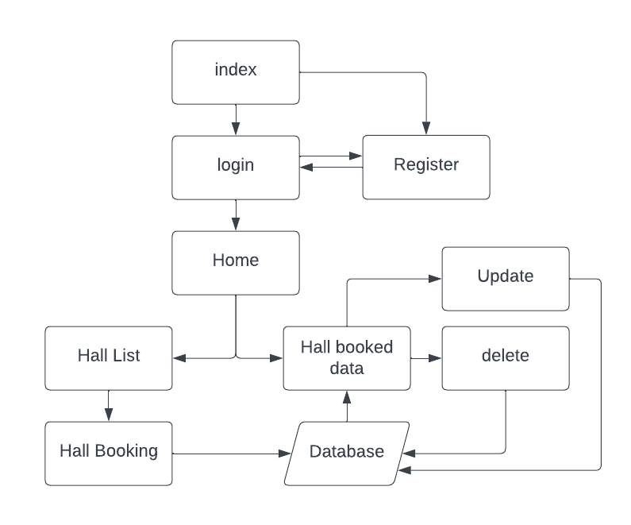

**ER DIAGRAM :**

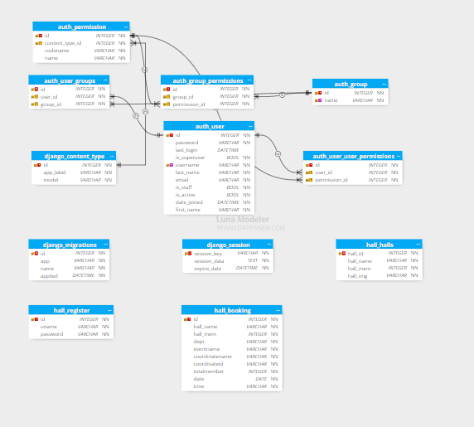

**TABLE DESIGN :**

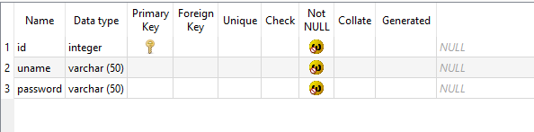

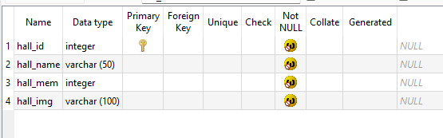

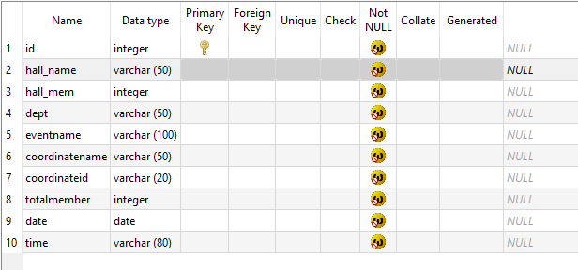

**Conclusion:**

In conclusion, the Seminar Hall Booking System (SHBS) presents a robust and efficient solution for managing seminar hall reservations within educational institutions. By leveraging technology, SHBS streamlines the process of booking seminar halls, enhancing user experience for both administrators and users alike.

With its user-friendly interface and intuitive functionalities, SHBS simplifies the task of finding and booking available seminar halls, reducing manual effort and minimizing errors. The system's modular architecture allows for easy customization and scalability, enabling institutions to tailor the system to their specific needs and accommodate future growth. Moreover, SHBS improves transparency and accountability in the booking process, providing administrators with comprehensive insights into hall occupancy, booking trends. This data-driven approach enables informed decision-making and optimization of resources, ultimately leading to more efficient use of seminar hall facilities.